

Benha University

***Faculty of computers And Artificial Intelligence***

***(BFCAI)***

**Brain Tumor Segmentation**

**Team Name**

**Ahmed Emad Nour**

**Abdel Moneim Elsayed Abdel Moneim**

**Ahmed Ayman Fathi Salama**

**Supervisor:**

**Prof/ Hala Zayed**

**Eng. Nada Baha**

**Brain Tumor Segmentation**

**Abstract**

**- At present, processing of medical images is a developing and important field. It includes many different types of imaging methods. Some of them are Computed Tomography scans (CT scans), X-rays and Magnetic Resonance Imaging (MRI) etc. These technologies allow us to detect even the smallest defects in the human body. Abnormal growth of tissues in the brain which affect proper brain functions is considered as a brain tumor. The main goal of medical image processing is to identify accurate and meaningful information using images with the minimum error possible. MRI is mainly used to get images of the human body and cancerous tissues because of its high resolution and better-quality images compared with other imaging technologies. Brain tumor identifications through MRI images is a difficult task because of the complexity of the brain. MRI images can be processed and the brain tumor can be segmented. These tumors can be segmented using various image segmentation techniques. The process of identifying brain tumors through MRI images can be categorized into four different sections; pre-processing, image segmentation, feature extraction.**

**INTRODUCTION**

**Brain tumors affect the humans badly, because of the abnormal growth of cells within the brain. It can disrupt proper brain function and be life-threatening. Two types of brain tumors have been identified as Benign tumors and Malignant tumors. Benign tumors are less harmful than malignant tumors as malignant are fast developing and harmful while benign are slow growing and less harmful. Medical imaging technique is used to create visual representation of interior of the human body for medical purposes and noninvasive possibilities can be diagnosed by this technology. The various types of medical imaging technologies based on noninvasive approach like; MRI, CT scan, Ultrasound, SPECT, PET and X-ray. When compared to other medical imaging techniques, Magnetic Resonance Imaging (MRI) is majorly used and it provides greater contrast images of the brain and cancerous tissues. Therefore, brain tumor identification can be done through MRI images. This paper focuses on the identification of brain tumor using image processing techniques. The rest of the paper describes, background of identification of brain tumor using image processing (. Section II) and. Section III presents the related work. Section IV provides a description about methodology while Section V gives an acknowledgement of the research.**

**BACKGROUND**

**Brain Tumor is described as abnormal development of tissues in the brain. Nowadays the prevalence of tumors is growing fast. In 2016, an estimated 23,800 adults. (10,350 women and 13,450 men) in the US will be identified with the harmful tumors of brain as well as spinal code. Analysis of brain tumors is somewhat problematic as the varied shape, size, tumor location and the presence and appearance of tumor in brain. It’s hard to detect brain tumors in beginning stage because the accurate measurement of tumor can’t be found. But once the brain tumor is identified at the very beginning, the proper treatments can be done and it may be curable. At present, visual representation of the interior of the body is processed using medical imaging technique for clinical analysis and medical researches. MRI is the most effective and extensively used technique for brain tumor detection. Current diagnosis techniques are performed using the conventional methods based on human experience and this increases the possibility of false detection when identifying brain tumors. Present tools and methods to analyze tumors and their behavior have become more prevalent. Image processing technique can be used to identify brain tumors. Image processing methods converts images into digital and do operations on them, in order to get better and enhanced images. This study will focus how to identify brain tumors using image processing techniques.**

**RELATED WORK**

**In recent years, image processing has applied to process images in medical stream, in cooperating cell detection. In 2012, ‘S. Mooched’ introduced several identification steps, including segmenting images to extract the object from the background through the threshold. This feature was introduced with the ‘Gabor filter’ in order to do more classification into cancer cells. In 2013, ‘H. G. Zadeh’ proposed further steps, which is image extraction and segmentation of images for diagnosing cancer cells. The Gaussian smoothing concept was introduced as a filtering purpose, previous to applying the ‘Fast Fourier Transform’ (FFT). Machine Learning. for tumor detection: ‘NN’, ‘Fuzzy. C-mean’ algorithms were introduced for the identification of tumorous cells. This takes lower computational time but the accuracy also lower. In 2014, ‘X. Chen’ introduces gene counting technology. But this technology is appropriate only for the complex formation of gene selection. From the above-mentioned techniques and using other technologies, in this research paper focuses on the identification of brain tumor using image processing techniques.**

METHODOLOGY

**According to the following steps, Brain tumors can be detected using Image Processing techniques.**

* **Input (MRI image).**
* **Pre-Processing.**
* **Image Segmentation.**
* **Morphological Operation**
* **Connected Components**
* **Classification.**
* **Image Pre-Processing:** It is very difficult to process an image. Before any image is processed, it is very significant to remove unnecessary items it may hold. After removing unnecessary artifacts, the image can be processed successfully. The initial step of image processing is Image Pre-Processing. Pre-Processing involves processes like conversion to greyscale image, noise removal and image reconstruction. Conversion to greyscale image is the most common pre-processing practice. After the image is converted to greyscale, then remove excess noise using different filtering methods.

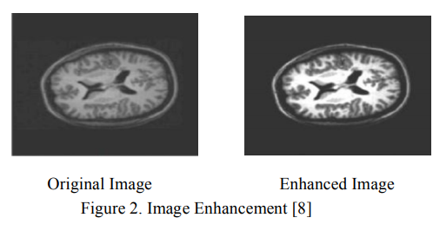

* **Median Filter:** This the most common technique which used for noise elimination. It is a ‘non-linear’ filtering technique. This is used to eliminate ‘Salt and Pepper noise’ form the greyscale image. Median filter is based on average value of pixels. The advantages of median filter are efficient in reducing Salt and Pepper noise and Speckle noise. Also, the edges and boundaries are preserved. The main disadvantages are complexity and time consumption as compared to mean filter.

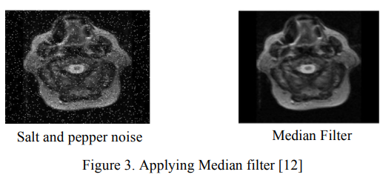

**Steps of brain tumor detection**

* **Mean Filter: This filter is also a de-noising filter that is based on average value of pixels. Advantages of mean filter are it reduces Gaussian noise and the response time is fast. Main disadvantage is it distorted boundaries and edges.**
* Morphology Based De-noising: This filter is based on Morphological operations of opening and closing. Producing results better than other de-noising filters and the efficiency are the main advantage of this filter.
* **Image Segmentation: Image Segmentation’ is the procedure of distributing an image into minor portions. It creates several sets of pixels within same image. Assigns a tag to every pixel in an image and the pixels with the similar label share particular features. Segmenting makes it easier to further analyze and recognize important information form a digital image.**
* **Threshold Segmentation: Segmentation’ is the technique that has been introduced to divide a digital image into number of segments that include sets of pixels and set of super pixels. Objectives to be accomplished through the process of segmentation are simplifying and changing the format of representation of an image in a way that it will become more detailed, meaningful and easy for the process of analysis. Placing of objects and boundaries in images such as lines, curves could be performed through Image segmentation. Throughout the procedure of image segmentation, every pixel in an image is assigned a label and the pixels consist of same label share certain visual features. Each pixel in the region is similar in relation to some features or computed properties, such as color, intensity or texture. Adjoining regions are particularly different in regard to the same features. Thresholding methodology is the simplest technique of image segmentation. This technique involves a threshold value that is used to converting a gray-scale featured image to a binary image. The major advantage of this method is selecting the threshold value to be used.**
* **Morphological Based Segmentation: ‘Morphology’ refers to describing the properties of the shape and structure of any entity. Binary images may comprise many defects. Particularly, the binary regions constructed by simple thresholding are deformed by texture and noise. Morphological image processing seeks to achieve the goals of eliminating these defects by accounting for image shape and structure. Generally, this denotes recognizing objects or boundaries within the image. Morphological operations are logical conversions based on comparison of pixel neighborhoods with a pattern. Usually, morphological operations are implemented on binary images under the pixel values; 0 or 1. Many of the morphological operations target on binary images.**

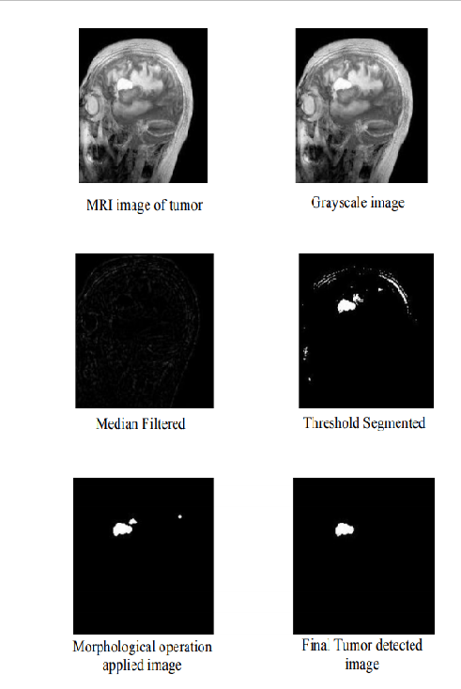

RESULTS

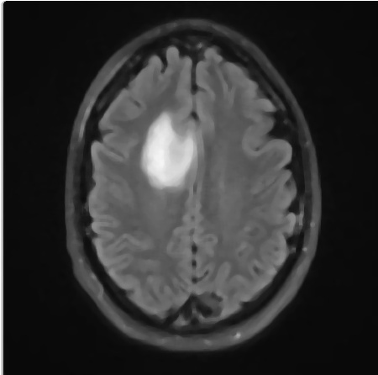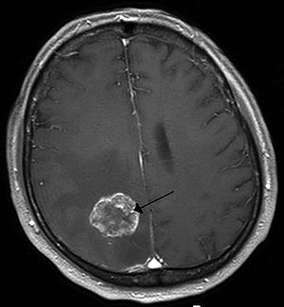



Threshold

Opening

Closing

Threshold image

Median Filter

Threshold

Median Filter

Median Filter

Gray Scale



Closing

Labeled Image

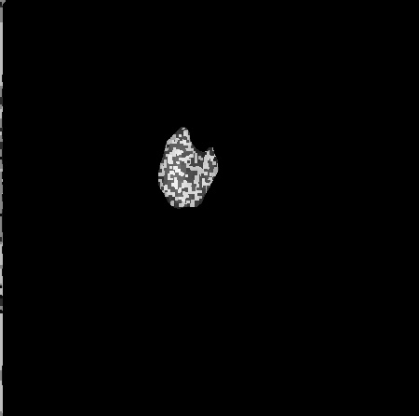

Non-Tumor

Tumor

Classification

Connected Components

Accuracy

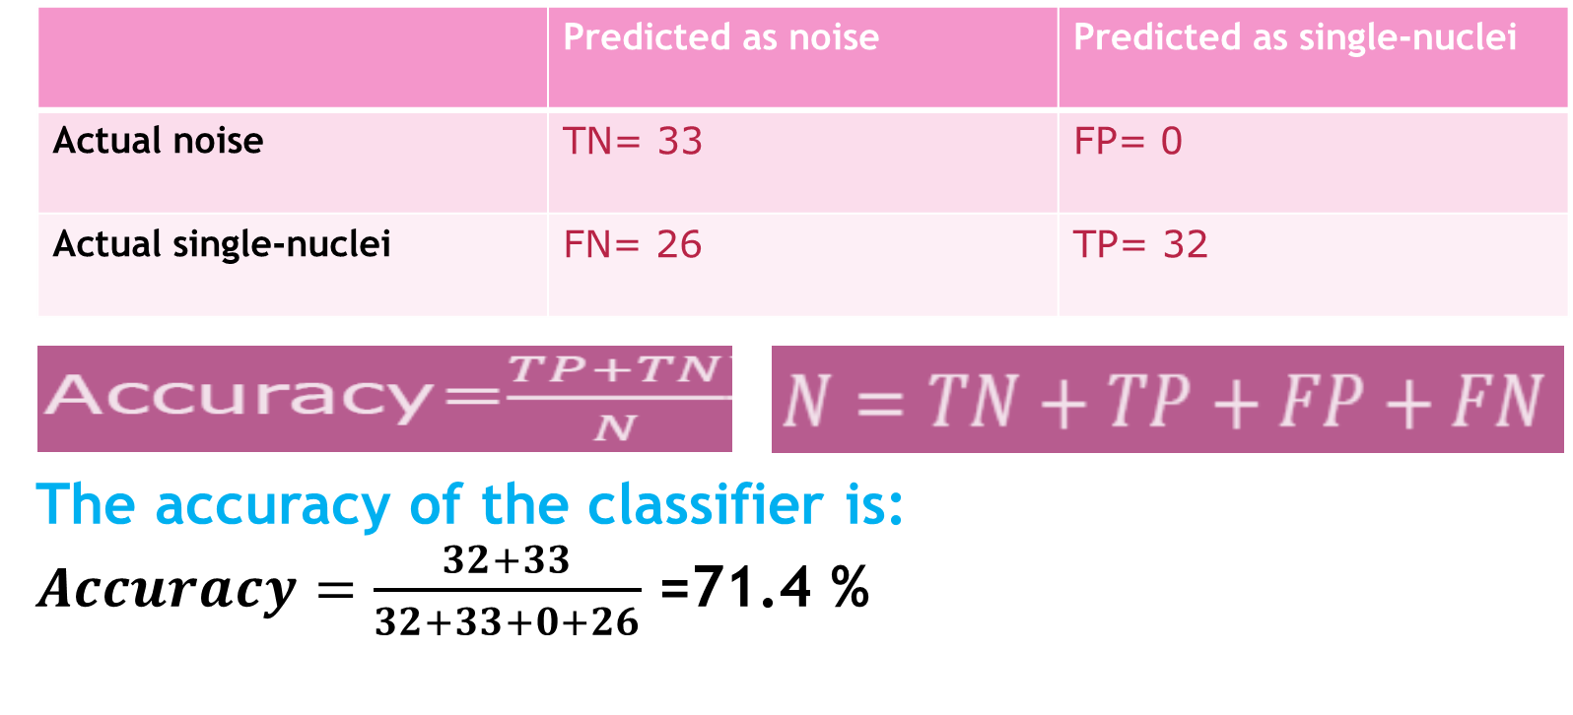

* Conclusion

**Brain tumor identifications through MRI images is a difficult task because of the complexity of the brain. These tumors can be segmented using various image segmentation techniques. The process of identifying brain tumors through MRI images can be categorized into four different sections; pre-processing which include Median filter which is the most commonly used filtering technique among various filtering techniques, image segmentation, and image classification.**